DAY-1 PROGRAMS

1. Write a R program to take input from the user (name and age) and display the

values. Also print the version of R installation.

2. Write a R program to get the details of the objects in memory.

3. Write a R program to create a sequence of numbers from 20 to 50 and find the

mean of numbers from 20 to 60 and sum of numbers from 51 to 91.

4. Write a R program to create a vector which contains 10 random integer values

between -50 and +50.

5. Write a R program to get the first 10 Fibonacci numbers.

6. Write a R program to get all prime numbers up to a given number (based on

the sieve of Eratosthenes).

7. Write a R program to print the numbers from 1 to 100 and print &quot;Fizz&quot; for

multiples of 3, print &quot;Buzz&quot; for multiples of 5, and print &quot;FizzBuzz&quot; for multiples of

both.

8. Write a R program to extract first 10 english letter in lower case and last 10

letters in upper case and extract letters between 22 nd  to 24 th  letters in upper case.

9. Write a R program to find the factors of a given number.

10. Write a R program to find the maximum and the minimum value of a given

vector.

11. Write a R program to get the unique elements of a given string and unique

numbers of vector.

12. Write a R program to create three vectors a,b,c with 3 integers. Combine the

three vectors to become a 3×3 matrix where each column represents a vector.

Print the content of the matrix.

13. Write a R program to create a list of random numbers in normal distribution

and count occurrences of each value.

14. Write a R program to read the .csv file and display the content.

15. Write a R program to create three vectors numeric data, character data and

logical data. Display the content of the vectors and their type.

16. Write a R program to create a 5 x 4 matrix , 3 x 3 matrix with labels and fill

the matrix by rows and 2 × 2 matrix with labels and fill the matrix by columns.

17. Write a R program to create an array, passing in a vector of values and a

vector of dimensions. Also provide names for each dimension.

18. Write a R program to create an array with three columns, three rows, and two

&quot;tables&quot;, taking two  vectors as input to the array.  Print the array.

19. Write a R program to create a list of elements using vectors, matrices and a

functions. Print the content of the list.

20. Write a R program to draw an empty plot and an empty plot specify the axes

limits of the graphic.

ANSWERS

1. PRINT THE VERSION

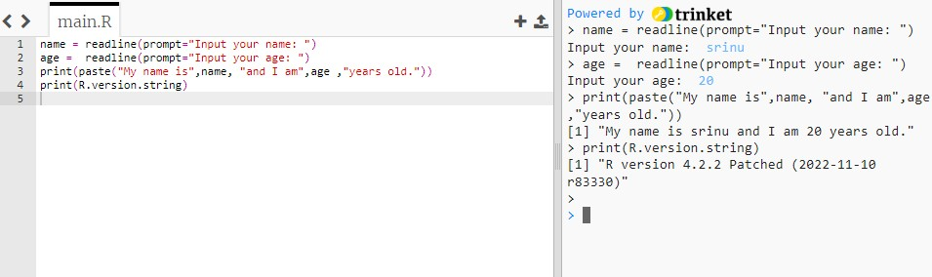

1. OBJECT IN MEMORY

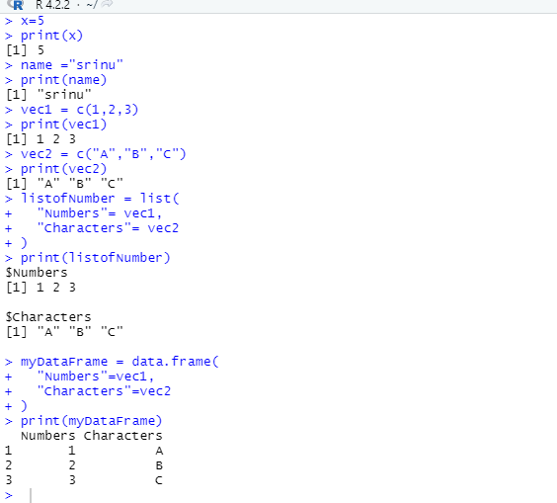

1. CREATE A SEQUENCE

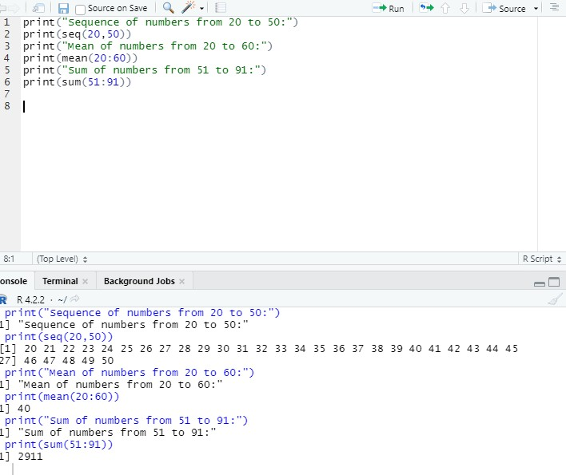

1. RANDOM INTEGER VALVES

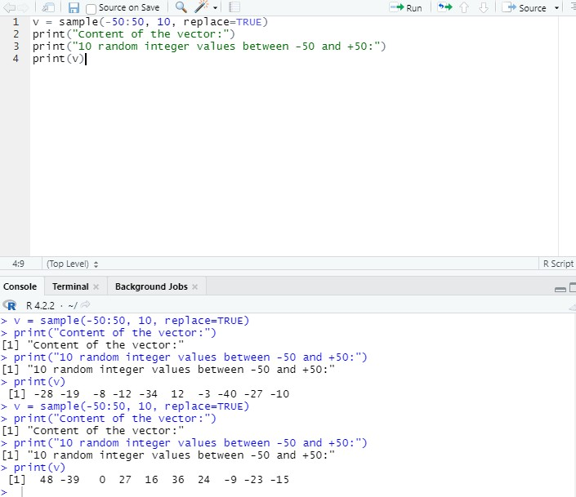

1. FIBONACCI NUMBERS

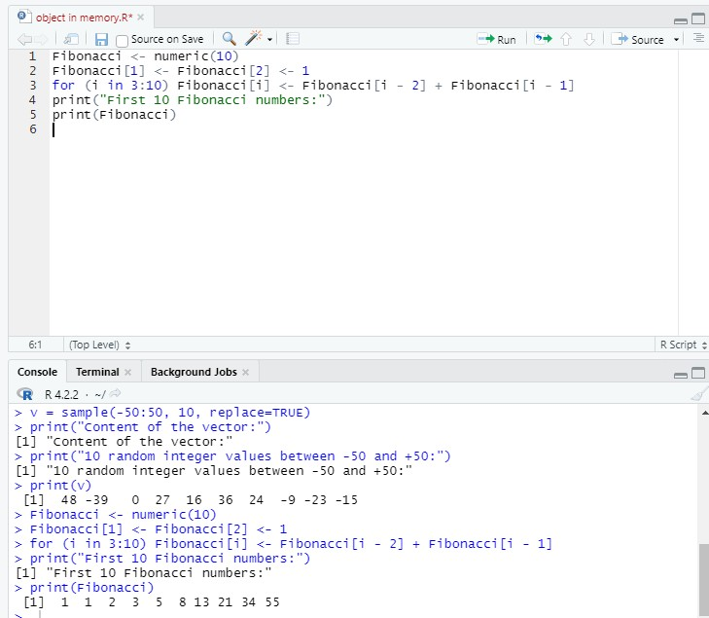

1. prime numbers

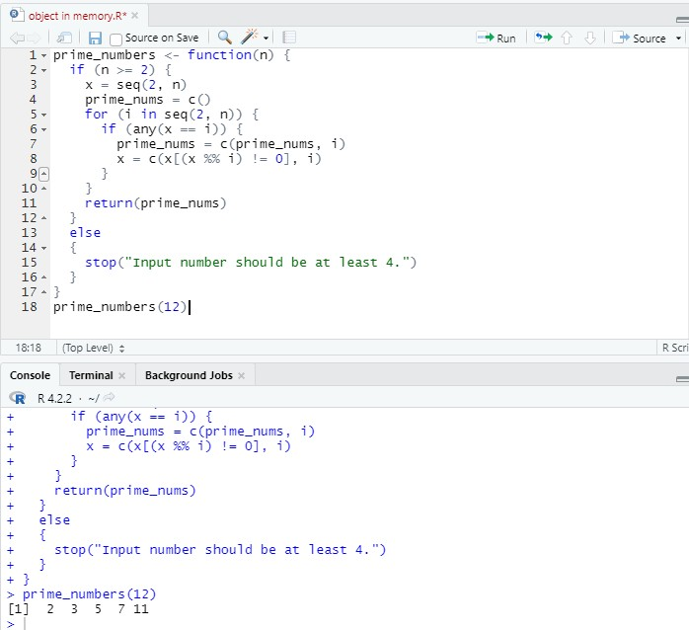

1. "fizz for muliples of muliples

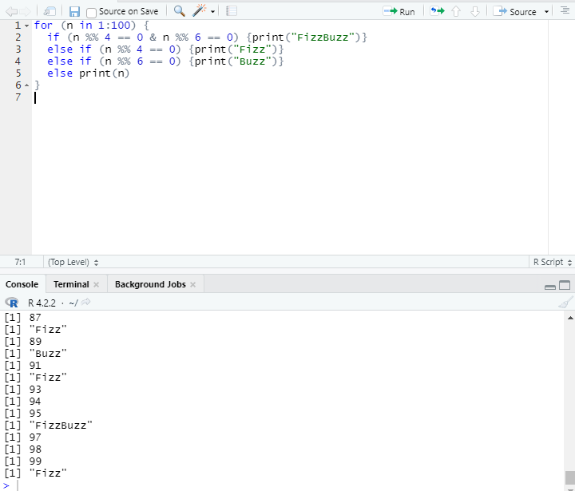

1. .R PROGAM TO PRINT THE FRIST ENGLISH

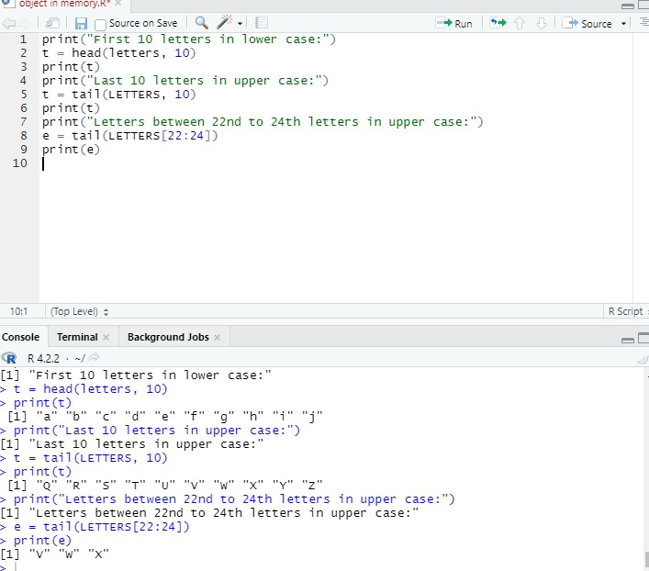

1. R PROGRAM TO FIND THE FACTORS

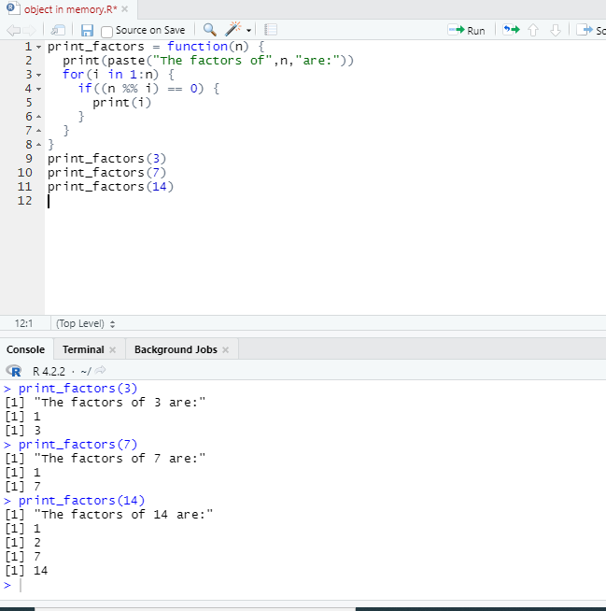

10.R PROGAM FOR MAXIMUM AND MINIMUM

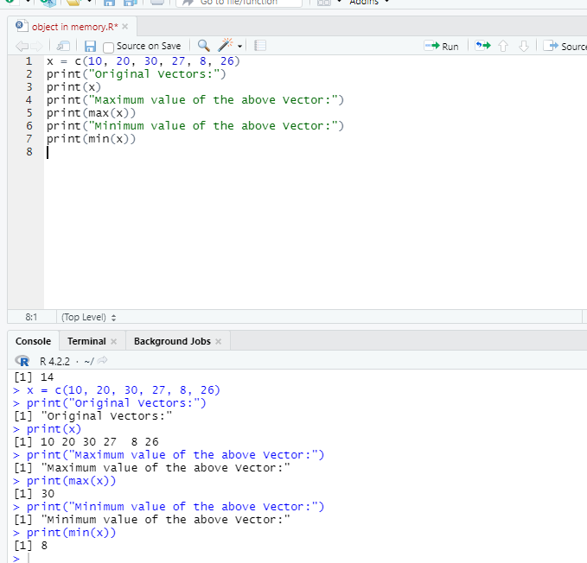

11 WRITE A R PROGRAM UNIQUE ELEMENTS

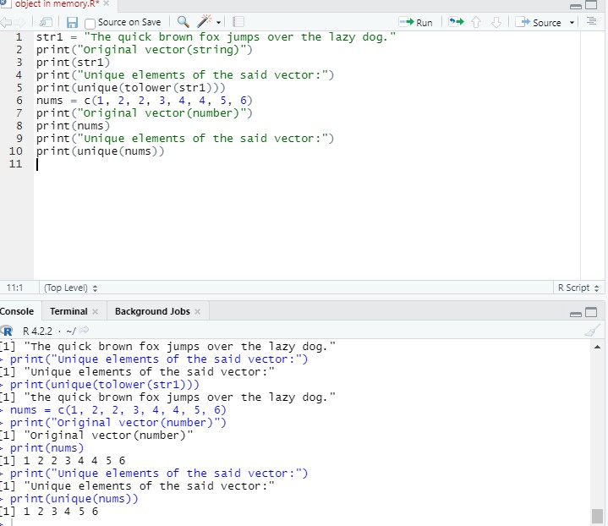

12.WRITE A R PROGAM CREATE THREE VECTORS

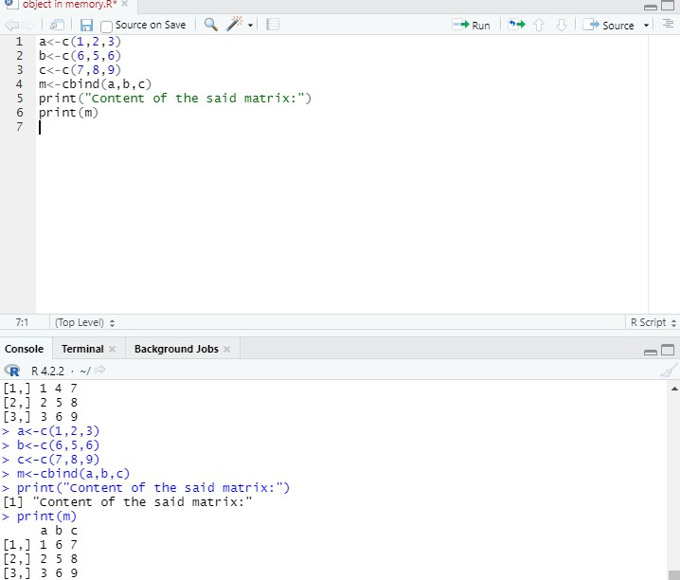

13.R PROGRAM NORMAL DISTRIBUTION

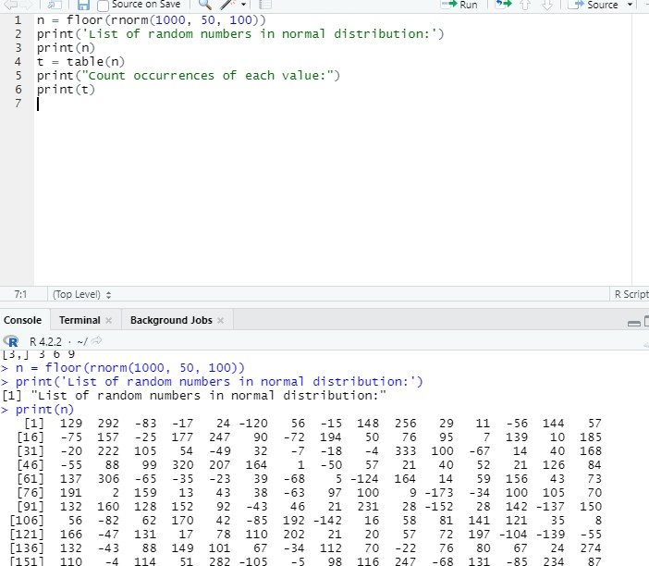

15.R PROGAM VECTORS NUMERIC DATA

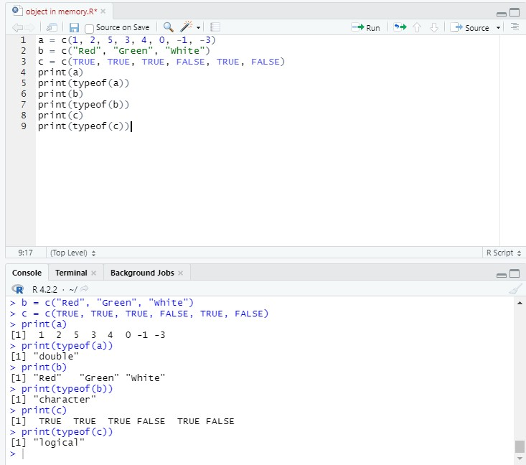

16.WRITE A R PROGAM TO CREATE 5\*4MATRIX AND 3\*3MATRIX

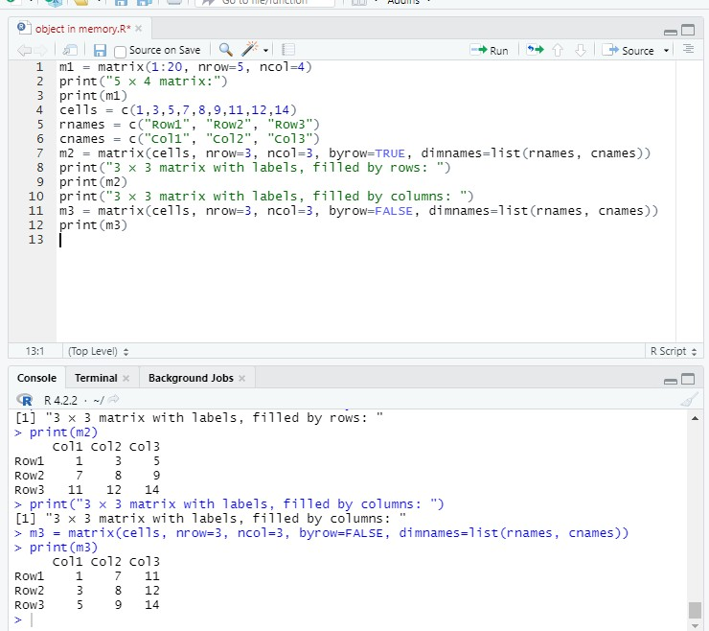

17 WRITE A R PROGRM CREATE AN ARRAY

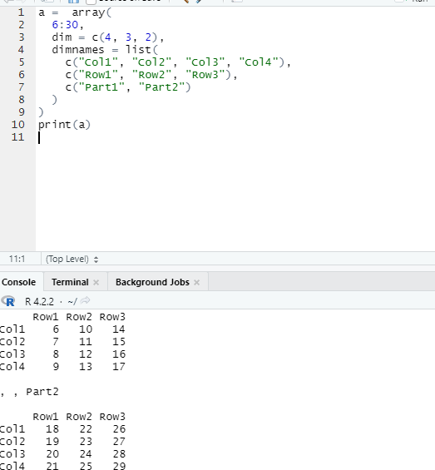

1. Write a R program to create an array with three columns

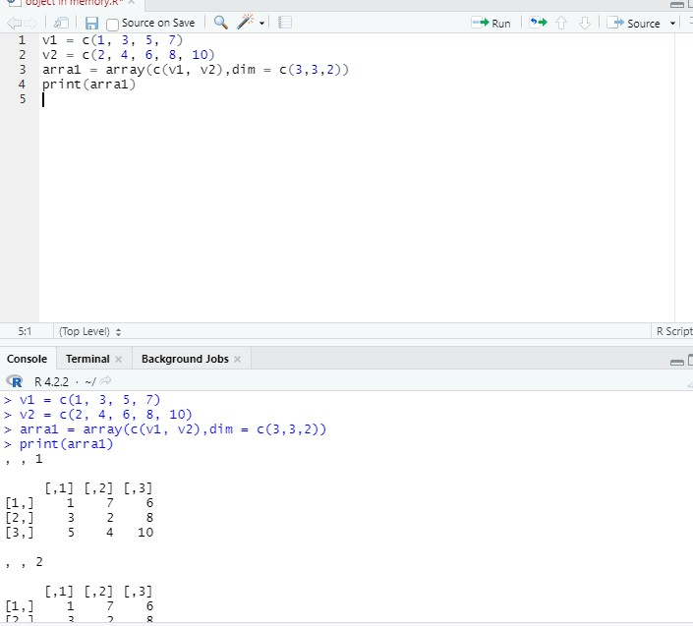

1. Write a R program to create a list of elements using vectors, matrices

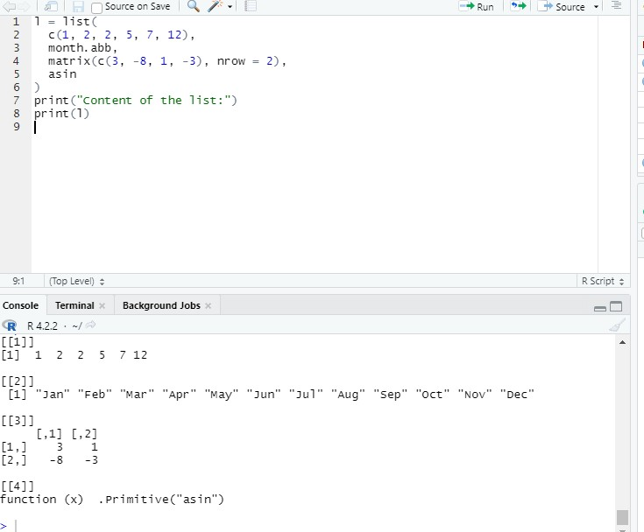

1. Write a R program to draw an empty plot and an empty plot specify the axes

